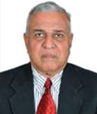

PROF. (DR.) K.K AGGARWAL

Prof. Aggarwal, obtained his Bachelor of Engineering Degree from Punjab University and Masters Degree from NIT, Kurukshetra. Later, he did his Ph.D also from NIT, Kurukshetra. After a distinguished service of 27 years at NIT, Kurukshetra, Prof. Aggarwal served as Pro Vice-Chancellor, GJU, Hisar for a period of three years, and then as Founder Vice Chancellor of GGS Indraprastha University, Delhi for a period of 10 years.
He has been President of the Institution of Electronics and Telecommunication Engineers (IETE) for the period 2002-2004, President, Computer Society of India from 2007-2009 and President of South East Asia Regional Computer Confederation (SEARCC) from 2008-10.
Prof. Aggarwal has been associated with NBA in various capacities since its inception and was Chairman, EEAC ( Tier-Il ) before taking over as Chairman, NBA on 14th January, 2019.

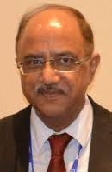

DR. ANIL KUMAR NASSA

Dr. Anil Kumar Nassa obtained his Bachelors Degree in Textile Chemistry from the Technological Institute of Textiles, Bhiwani, Masters Degree in Fibre Science and Technology and Doctoral Degree on the theses titled "Technical Education System: Accreditation Process and Improvements" from IIT, Delhi.
He served in different capacities in various Textile Industries. He joined Department of Higher Education Ministry of Human Resource Development, Government of India, in 1990 and was working as Deputy Educational Advisor (Technical) before joining National Board of Accreditation as Member Secretary.
Dr. Nassa has dealt with various important development schemes of Technical Education in the Ministry of HRD, AICTE and has contributed significantly in the planning, formulation and implementation of various schemes of Technical Education. He had been associated with the Approval and Accreditation of Technical Institutions/Programmes at Regional as well as National level in AICTE.
He has more than 10 research papers to his credit in reputed National and International Journals and National and International Conferences

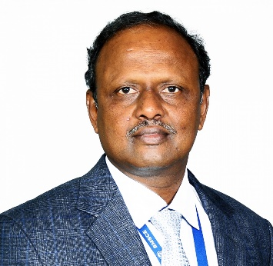

Dr. R. V. RANGANATH
Obtained B.E.,(Civil Engineering) degree from National Institute of Engineering, Mysore University, M.Tech and Ph.D. from IIT Delhi. Research interests include Fly ash/pond ash Concrete, Self-Compacting Concrete (SCC), Geopolymer Concrete using Fly Ash, Slag and other industrial by-products. Recipient of AICTE Career Award for Young Teachers in 1998 and “ICI-FOSROC Award for Outstanding Concrete Technologist for the year 2011 at by Indian Concrete Institute, (Chennai) at National level. Served as HOD, Civil Engineering, Dean Academics at BMSCE and Principal in BMS Institute of Technology, Yelahanka, Bengaluru on deputation during 2014-2015. At present, actively involved in implementation of Outcomes Based Education (OBE) in Engineering Institutions through NBA awareness programmes and Evaluators training programmes as resource person.

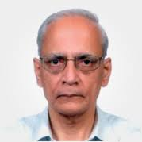 C R Muthukrishnan

Prof Muthukrishnan has been Consulting Advisor to ceo, TCS, Deputy Director & Director-in-charge, IIT Madras and Professor of Computer Science& Engineering at IIT Madras in his career spanning 40 years He has guided 30 Research scholars for PhD and MS degrees, over 300students for MTech and BTech projects. Many of his students are holding top positions in academia and in reputed companies globally and many as entrepreneurs have created startups and developed them successfully.
He is actively engaged in Accreditation work for NBA and NAAC for about five years now. He consults for academic institutions and industry.
A chair in Computational Brain Research has been established in 2016 at IIT Madras by K.S Gopalakrishnan, his former student and co-founder of Infosys Limited.
He is a BTech (Hons) President Prize awardee for general proficiency from IIT Madras, MTech and PhD (1969) from IIT Kanpur.

